**JavaScript Form Validation for a ‘Registration Form’**

**Reference:**

https://www.w3resource.com/javascript/form/example-javascript-form-validation.html

**Table of Contents**

Snap of the Registration form with validation conditions: 3

HTML Code of the Sample Registration Form 3

CSS Code of the Sample Registration Form 4

JavaScript code for validation 5

JavaScript function for validating userid 5

Flowchart: 6

JavaScript function for validating password 6

Flowchart: 7

JavaScript code for validating user name 7

Flowchart: 7

JavaScript code for validating user address 8

Flowchart: 8

JavaScript code for validating country 9

Flowchart: 9

JavaScript code for validating ZIP code 10

Flowchart: 10

JavaScript code for validating email format 11

Flowchart: 11

JavaScript code for validating gender 12

Flowchart: 12

Entire JavaScript used for validation of the form. 13

Flowchart: 16

# Snap of the Registration form with validation conditions:

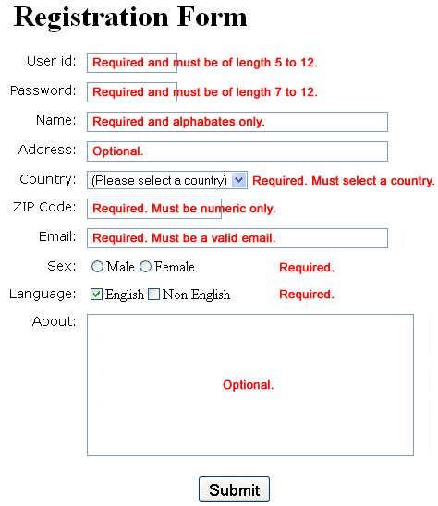

# HTML Code of the Sample Registration Form

<!DOCTYPE html>

<html lang="en"><head>

<meta charset="utf-8">

<title>JavaScript Form Validation using a sample registration form</title>

<meta name="keywords" content="example, JavaScript Form Validation, Sample registration form" />

<meta name="description" content="This document is an example of JavaScript Form Validation using a sample registration form. " />

<link rel='stylesheet' href='js-form-validation.css' type='text/css' />

<script src="sample-registration-form-validation.js"></script>

</head>

<body onload="document.registration.userid.focus();">

<h1>Registration Form</h1>

Use tab keys to move from one input field to the next.

<form name='registration' onSubmit="return formValidation();">

<ul>

<li><label for="userid">User id:</label></li>

<li><input type="text" name="userid" size="12" /></li>

<li><label for="passid">Password:</label></li>

<li><input type="password" name="passid" size="12" /></li>

<li><label for="username">Name:</label></li>

<li><input type="text" name="username" size="50" /></li>

<li><label for="address">Address:</label></li>

<li><input type="text" name="address" size="50" /></li>

<li><label for="country">Country:</label></li>

<li><select name="country">

<option selected="" value="Default">(Please select a country)</option>

<option value="AF">Australia</option>

<option value="AL">Canada</option>

<option value="DZ">India</option>

<option value="AS">Russia</option>

<option value="AD">USA</option>

</select></li>

<li><label for="zip">ZIP Code:</label></li>

<li><input type="text" name="zip" /></li>

<li><label for="email">Email:</label></li>

<li><input type="text" name="email" size="50" /></li>

<li><label id="gender">Sex:</label></li>

<li><input type="radio" name="msex" value="Male" /><span>Male</span></li>

<li><input type="radio" name="fsex" value="Female" /><span>Female</span></li>

<li><label>Language:</label></li>

<li><input type="checkbox" name="en" value="en" checked /><span>English</span></li>

<li><input type="checkbox" name="nonen" value="noen" /><span>Non English</span></li>

<li><label for="desc">About:</label></li>

<li><textarea name="desc" id="desc"></textarea></li>

<li><input type="submit" name="submit" value="Submit" /></li>

</ul>

</form>

</body>

</html>

# CSS Code of the Sample Registration Form

h1 {

margin-left: 70px;

}

form li {

list-style: none;

margin-bottom: 5px;

}

form ul li label{

float: left;

clear: left;

width: 100px;

text-align: right;

margin-right: 10px;

font-family:Verdana, Arial, Helvetica, sans-serif;

font-size:14px;

}

form ul li input, select, span {

float: left;

margin-bottom: 10px;

}

form textarea {

float: left;

width: 350px;

height: 150px;

}

[type="submit"] {

clear: left;

margin: 20px 0 0 230px;

font-size:18px

}

p {

margin-left: 70px;

font-weight: bold;

}

# JavaScript code for validation

function formValidation()

{

var uid = document.registration.userid;

var passid = document.registration.passid;

var uname = document.registration.username;

var uadd = document.registration.address;

var ucountry = document.registration.country;

var uzip = document.registration.zip;

var uemail = document.registration.email;

var umsex = document.registration.msex;

var ufsex = document.registration.fsex; if(userid_validation(uid,5,12))

{

if(passid_validation(passid,7,12))

{

if(allLetter(uname))

{

if(alphanumeric(uadd))

{

if(countryselect(ucountry))

{

if(allnumeric(uzip))

{

if(ValidateEmail(uemail))

{

if(validsex(umsex,ufsex))

{

}

}

}

}

}

}

}

}

return false;

}

# JavaScript function for validating userid

function userid_validation(uid,mx,my)

{

var uid_len = uid.value.length;

if (uid_len == 0 || uid_len >= my || uid_len < mx)

{

alert("User Id should not be empty / length be between "+mx+" to "+my);

uid.focus();

return false;

}

return true;

}

## Flowchart:

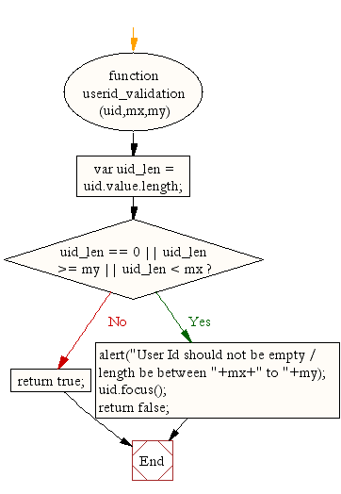

# JavaScript function for validating password

function passid_validation(passid,mx,my)

{

var passid_len = passid.value.length;

if (passid_len == 0 ||passid_len >= my || passid_len < mx)

{

alert("Password should not be empty / length be between "+mx+" to "+my);

passid.focus();

return false;

}

return true;

}

## Flowchart:

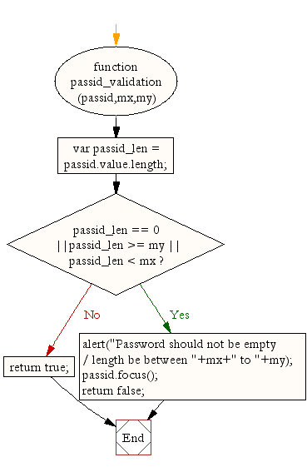

# JavaScript code for validating user name

function allLetter(uname)

{

var letters = /^[A-Za-z]+$/;

if(uname.value.match(letters))

{

return true;

}

else

{

alert('Username must have alphabet characters only');

uname.focus();

return false;

}

}

## Flowchart:

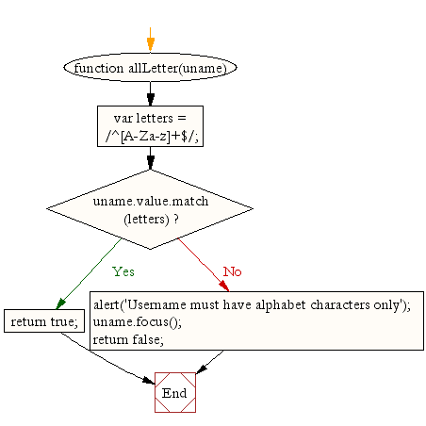

# JavaScript code for validating user address

function alphanumeric(uadd)

{

var letters = /^[0-9a-zA-Z]+$/;

if(uadd.value.match(letters))

{

return true;

}

else

{

alert('User address must have alphanumeric characters only');

uadd.focus();

return false;

}

}

## Flowchart:

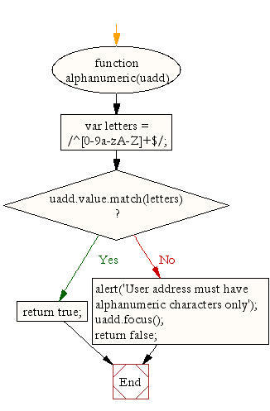

# JavaScript code for validating country

function countryselect(ucountry)

{

if(ucountry.value == "Default")

{

alert('Select your country from the list');

ucountry.focus();

return false;

}

else

{

return true;

}

}

## Flowchart:

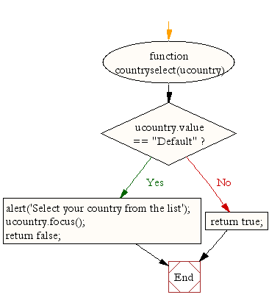

# JavaScript code for validating ZIP code

function allnumeric(uzip)

{

var numbers = /^[0-9]+$/;

if(uzip.value.match(numbers))

{

return true;

}

else

{

alert('ZIP code must have numeric characters only');

uzip.focus();

return false;

}

}

## Flowchart:

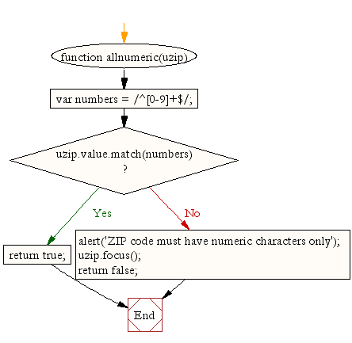

# JavaScript code for validating email format

function ValidateEmail(uemail)

{

var mailformat = /^\w+([\.-]?\w+)*@\w+([\.-]?\w+)*(\.\w{2,3})+$/;

if(uemail.value.match(mailformat))

{

return true;

}

else

{

alert("You have entered an invalid email address!");

uemail.focus();

return false;

}

}

## Flowchart:

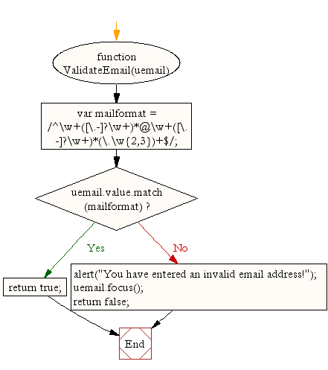

# JavaScript code for validating gender

function validsex(umsex,ufsex)

{

x=0;

if(umsex.checked)

{

x++;

} if(ufsex.checked)

{

x++;

}

if(x==0)

{

alert('Select Male/Female');

umsex.focus();

return false;

}

else

{

alert('Form Successfully Submitted');

window.location.reload()

return true;}

}

## Flowchart:

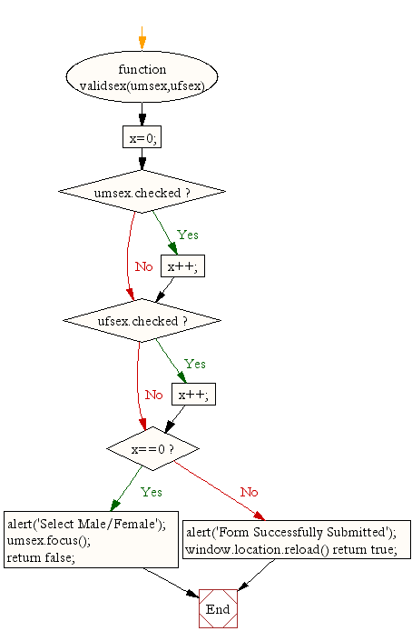

# Entire JavaScript used for validation of the form.

function formValidation()

{

var uid = document.registration.userid;

var passid = document.registration.passid;

var uname = document.registration.username;

var uadd = document.registration.address;

var ucountry = document.registration.country;

var uzip = document.registration.zip;

var uemail = document.registration.email;

var umsex = document.registration.msex;

var ufsex = document.registration.fsex; if(userid_validation(uid,5,12))

{

if(passid_validation(passid,7,12))

{

if(allLetter(uname))

{

if(alphanumeric(uadd))

{

if(countryselect(ucountry))

{

if(allnumeric(uzip))

{

if(ValidateEmail(uemail))

{

if(validsex(umsex,ufsex))

{

}

}

}

}

}

}

}

}

return false;

} function userid_validation(uid,mx,my)

{

var uid_len = uid.value.length;

if (uid_len == 0 || uid_len >= my || uid_len < mx)

{

alert("User Id should not be empty / length be between "+mx+" to "+my);

uid.focus();

return false;

}

return true;

}

function passid_validation(passid,mx,my)

{

var passid_len = passid.value.length;

if (passid_len == 0 ||passid_len >= my || passid_len < mx)

{

alert("Password should not be empty / length be between "+mx+" to "+my);

passid.focus();

return false;

}

return true;

}

function allLetter(uname)

{

var letters = /^[A-Za-z]+$/;

if(uname.value.match(letters))

{

return true;

}

else

{

alert('Username must have alphabet characters only');

uname.focus();

return false;

}

}

function alphanumeric(uadd)

{

var letters = /^[0-9a-zA-Z]+$/;

if(uadd.value.match(letters))

{

return true;

}

else

{

alert('User address must have alphanumeric characters only');

uadd.focus();

return false;

}

}

function countryselect(ucountry)

{

if(ucountry.value == "Default")

{

alert('Select your country from the list');

ucountry.focus();

return false;

}

else

{

return true;

}

}

function allnumeric(uzip)

{

var numbers = /^[0-9]+$/;

if(uzip.value.match(numbers))

{

return true;

}

else

{

alert('ZIP code must have numeric characters only');

uzip.focus();

return false;

}

}

function ValidateEmail(uemail)

{

var mailformat = /^\w+([\.-]?\w+)*@\w+([\.-]?\w+)*(\.\w{2,3})+$/;

if(uemail.value.match(mailformat))

{

return true;

}

else

{

alert("You have entered an invalid email address!");

uemail.focus();

return false;

}

} function validsex(umsex,ufsex)

{

x=0;

if(umsex.checked)

{

x++;

} if(ufsex.checked)

{

x++;

}

if(x==0)

{

alert('Select Male/Female');

umsex.focus();

return false;

}

else

{

alert('Form Succesfully Submitted');

window.location.reload()

return true;

}

}

## Flowchart:

